Linux Privilege Escalation: Weak File Permissions

Privilege escalation is one of the most critical phases of a security assessment. This document focuses on Linux environments, highlighting how improper or weak file permission settings can be leveraged by attackers to escalate privileges and gain unauthorized access.

I take tryhackme room: https://tryhackme.com/room/linuxprivesc
First connect with the IP address of targeted machine
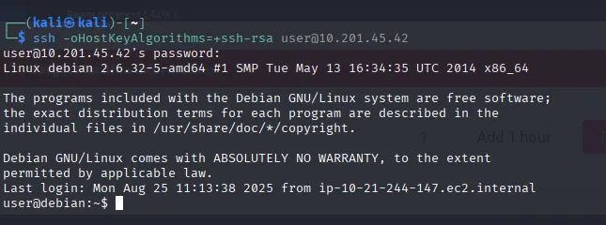
Write ls -la to see all the list of the files and directory
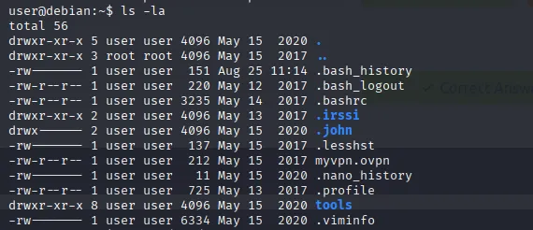

There are the files in /etc/passwd that stores basic information about all users on the system.
There are the files in /etc/shadow that stores hashed passwords and related security details.
There are the files in /etc/sudoers that controls who can run commands as root or other users using sudo.

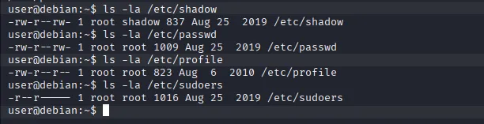
If you see the /etc/passwd
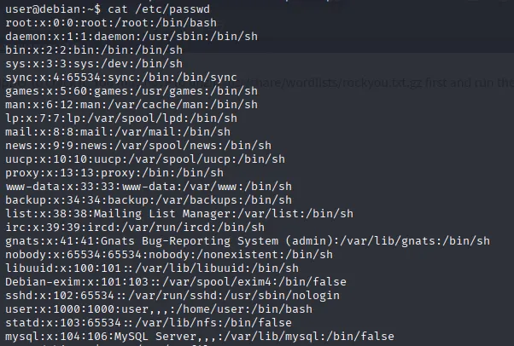
If you see /etc/profile
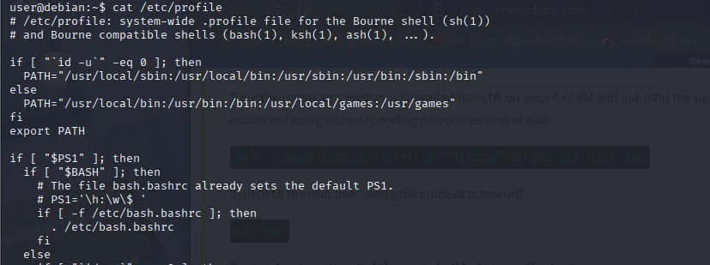

If you see /etc/shadow
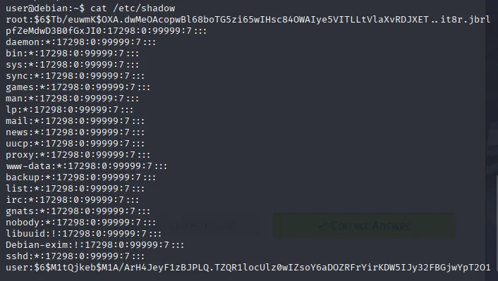

Attack Scenario:
If an attacker gets root privileges by write access to /etc/shadow, they can replace the root password hash and gain persistent root access.
You already see above /etc/shadow in root you see the HASH that hash I try to change and get root privilege.
Start Netcat Listener:
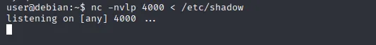
Establish connection to your system:
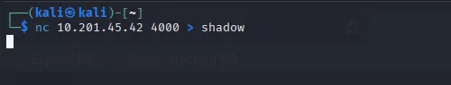
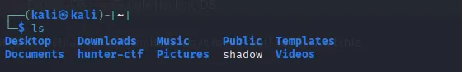

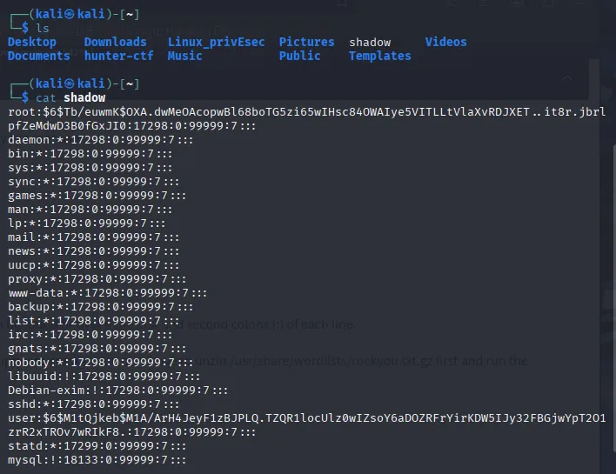

Make a fake hash using OpenSSL
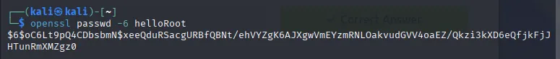
OpenSSL is an open-source cryptographic library and toolkit that implements the Transport Layer Security (TLS) and Secure Sockets Layer (SSL) protocols to enable secure communication and data encryption on networks.

Key Functions and Features
- TLS/SSL Protocol Implementation
- Cryptographic Library
- Certificate Management
- Key Generation
- Data Integrity and Random Number Generation

Change the real hash into fake hash
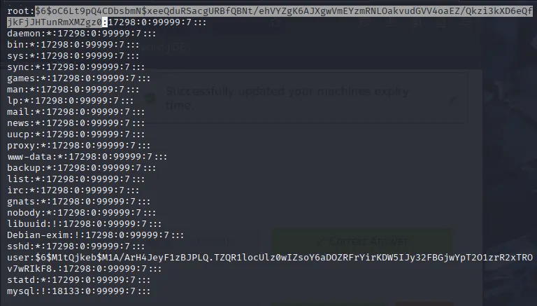

Then send the file to the target
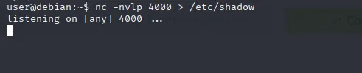

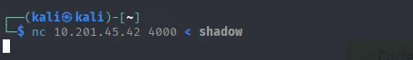

Now you can see the hash was changed and file was transferred successfully.
Then you see I able to root login with fake hash.
Password: helloRoot

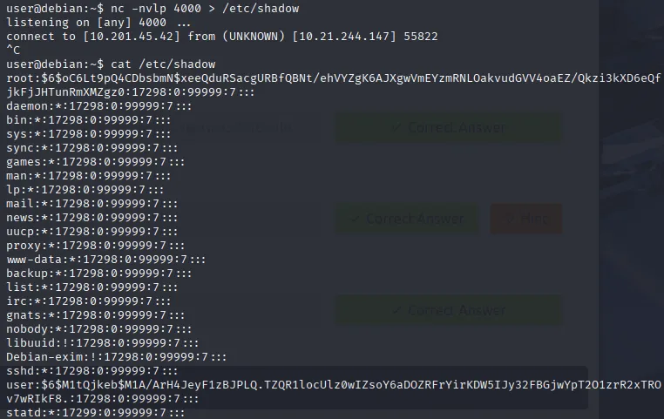

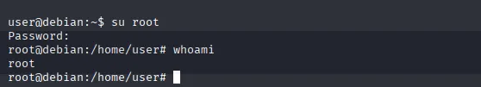

Attack Scenario:
If an attacker gets root privileges by Read Permission to /etc/shadow, they cannot directly change the root password but can steal password hashes. With these hashes, they can perform offline cracking to recover passwords, potentially leading to privilege escalation or lateral movement.
If you able to find a hash then you easily decrypt it and find a correct password.
You can use tools like: john the ripper, hashcat etc.

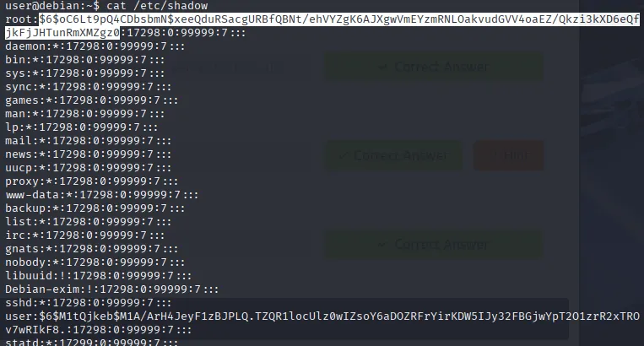

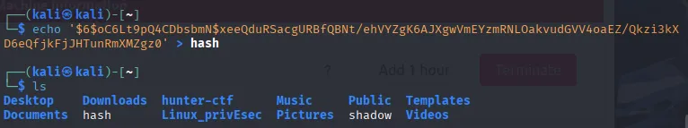

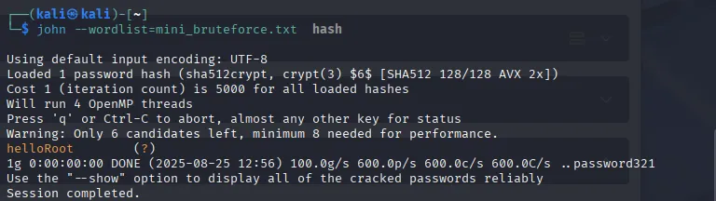

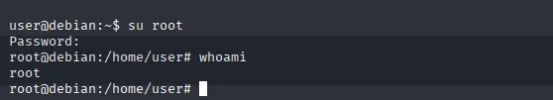

Attack Scenario:
If attacker gains write permissions to /etc/passwd**, they can create or modify user accounts and effectively gain root access without needing /etc/shadow.
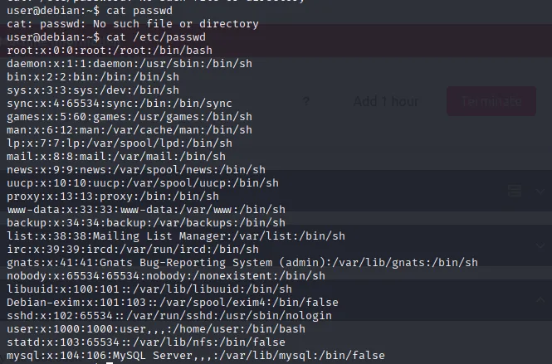

Start Netcat Listener:
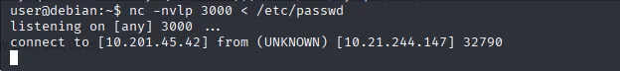

Now I remove the ‘x’ in root and add fake hash as a password.
You can see with this I get root access.

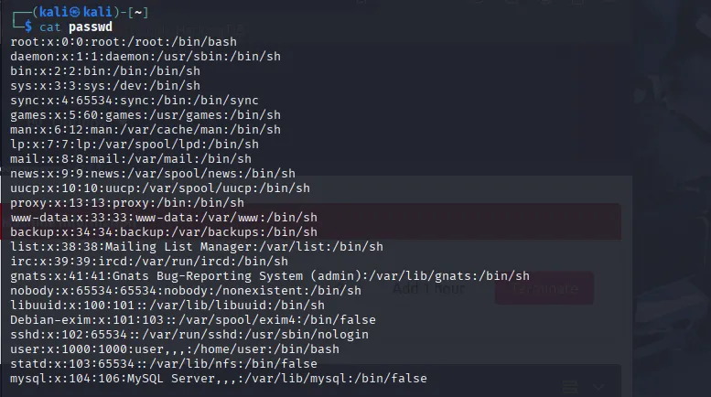

Make a fake hash
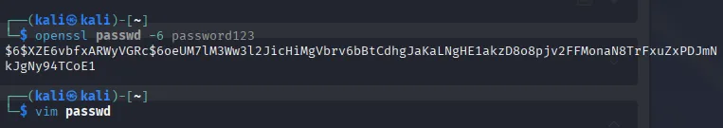
Paste that fake hash into /etc/passwd file and send it to the target
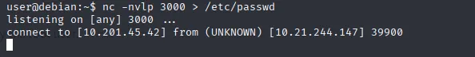
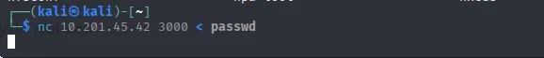

You they see you able to get root access

Conclusion
The /etc/shadow, /etc/passwd, and /etc/sudoers files are critical components of Linux system security. Misconfigurations or improper permissions on these files can directly lead to privilege escalation or full system compromise.
- Read access to /etc/shadow allows attackers to extract and crack password hashes offline, bypassing account lockout policies.
- Write access to /etc/passwd enables attackers to create or modify accounts with root privileges, gaining instant system control.
- Similar risks exist with /etc/sudoers misconfigurations, where incorrect rules can provide unauthorized administrative access.
Ensuring strict file permissions, enforcing least privilege principles, and implementing file integrity monitoring are essential steps to protect these files. Regular audits, strong password policies, and the use of modern authentication methods (like PAM, MFA, and strong hashing algorithms) further reduce risk, helping maintain a secure and hardened Linux environment.

